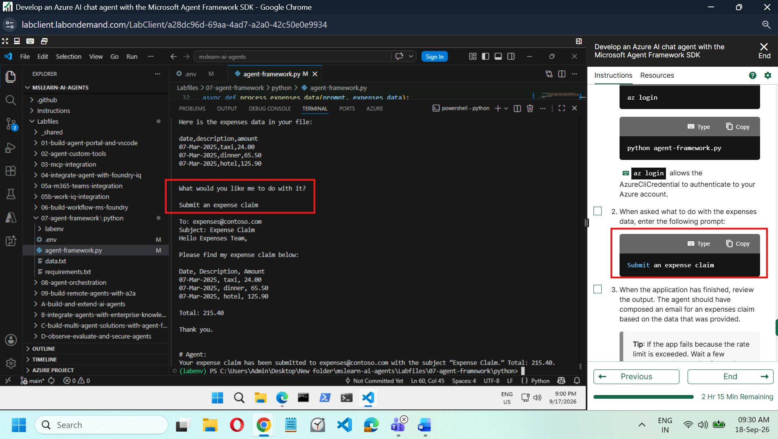

Code :

import os
import asyncio
from pathlib import Path
from dotenv import load_dotenv

# Add references
# Add references
from agent_framework import tool, Agent
from agent_framework.foundry import FoundryChatClient
from azure.identity import AzureCliCredential
from pydantic import Field
from typing import Annotated

load_dotenv()

async def main():
# Clear the console
os.system('cls' if os.name=='nt' else 'clear')

# Load the expnses data file
script_dir = Path(__file__).parent
file_path = script_dir / 'data.txt'
with file_path.open('r') as file:
data = file.read() + "\n"

# Ask for a prompt
user_prompt = input(f"Here is the expenses data in your file:\n\n{data}\n\nWhat would you like me to do with it?\n\n")

# Run the async agent code
await process_expenses_data(user_prompt, data)

async def process_expenses_data(prompt, expenses_data):

# Create a foundry chat client
# Create a foundry chat client
client = FoundryChatClient(
project_endpoint=os.getenv("PROJECT_ENDPOINT"),
model=os.getenv("MODEL_DEPLOYMENT_NAME"),
credential=AzureCliCredential()
)

# Initialize an agent with the tool and instructions
# Initialize an agent with the tool and instructions
async with (
Agent(
client=client,
name="ExpenseClaimAgent",
instructions="""You are an AI assistant for expense claim submission.
At the user's request, create an expense claim and use the plug-in function to send an email to expenses@contoso.com with the subject 'Expense Claim`and a body that contains itemized expenses with a total.
Then confirm to the user that you've done so. Don't ask for any more information from the user, just use the data provided to create the email.""",
tools=[submit_claim],
) as agent,
):

# Use the agent to process the expenses data
# Use the agent to process the expenses data
try:
# Add the input prompt to a list of messages to be submitted
prompt_messages = [f"{prompt}: {expenses_data}"]
# Invoke the agent for the specified thread with the messages
response = await agent.run(prompt_messages)
# Display the response
print(f"\n# Agent:\n{response}")
except Exception as e:
# Something went wrong
print (e)

# Create a tool function for the email functionality
# Create a tool function for the email functionality
@tool(approval_mode="never_require")
def submit_claim(
to: Annotated[str, Field(description="Who to send the email to")],
subject: Annotated[str, Field(description="The subject of the email.")],
body: Annotated[str, Field(description="The text body of the email.")]):
print("\nTo:", to)
print("Subject:", subject)
print(body, "\n")

if __name__ == "__main__":
asyncio.run(main())

